Progress Report 2

Eastern Intitute of Technology ITPM5.240 Agile Projects 2024

Luan Mangels, Alex Bourk, Anthony Nguyen, Hunter Mends

# **Group Contributions and reflection:**

## *Group Reflections:*

Splitting the workload for iteration 2 made it feel a lot easier to get through. Luan oversaw managing the tasks that each group member needs to contribute as well as writing up the meeting report and progress report with input from the rest of our group. Alex oversaw creating the GitHub boards as well as any other in class task that needed doing using GitHub. Anthony oversaw managing tasks and progress made on them. Lastly Hunter was put in charge of managing time and theoretical money spent in our project with the resource requirements list.

As a whole we feel like iteration 2 went a lot smoother compared to iteration 1. This was thanks to the implementation of multiple progress tracking tools like GitHub and a Gantt chart. We still had some issues however. The issues we had during iteration 2 were exclusively to do with the scheduling of meetings, this was because the time that we set up for them to be held was over our 2-week break. Group members had some things planned over this period and unfortunately we didn’t account for this during the planning section. In the end we we’re able to settle on times and dates and managed to finish all the discussions with enough time left over for the progress report to be completed.

## *Individual contributions:*

Luan Mangels – The first of my contributions was to go back to our personas with Alex and improve the descriptions of 2 personas that were made too brief for the task, this was critiqued in the feedback given to us after iteration 1. Secondly my contributions for iteration too were largely the dividing of tasks, scheduling meetings with members, discussing their experience with each task by writing the meeting report for iteration 2, writing the progress report for iteration 2 and lastly, majority of the communication on teams making sure that everyone is still on track.

Alex Bourk – I took the Gantt chart that Anthony made and went through the process of converting the information from there onto the GitHub boards page, specifically marking the iteration 1 work as complete, and marking the iteration 2 work as “in- progress or to-do”. Eventually these were also marked as complete but only after confirming with the group member that worked on each respective task.

Anthony Nguyen – My contribution to iteration 2 consists of the creation of the Gantt chart mostly as well as keeping track of progress and deadlines.

Hunter Mends – My contributions to iteration 2 were creating the Resource Requirements list and filling in my part of the meeting report.

# **Evidence of work:**

## *Revisiting Personas (Alex & Luan):*

## *Gantt Chart (Anthony):*

## *Resource Requirements List (Hunter):*

## *GitHub Boards (Alex):*

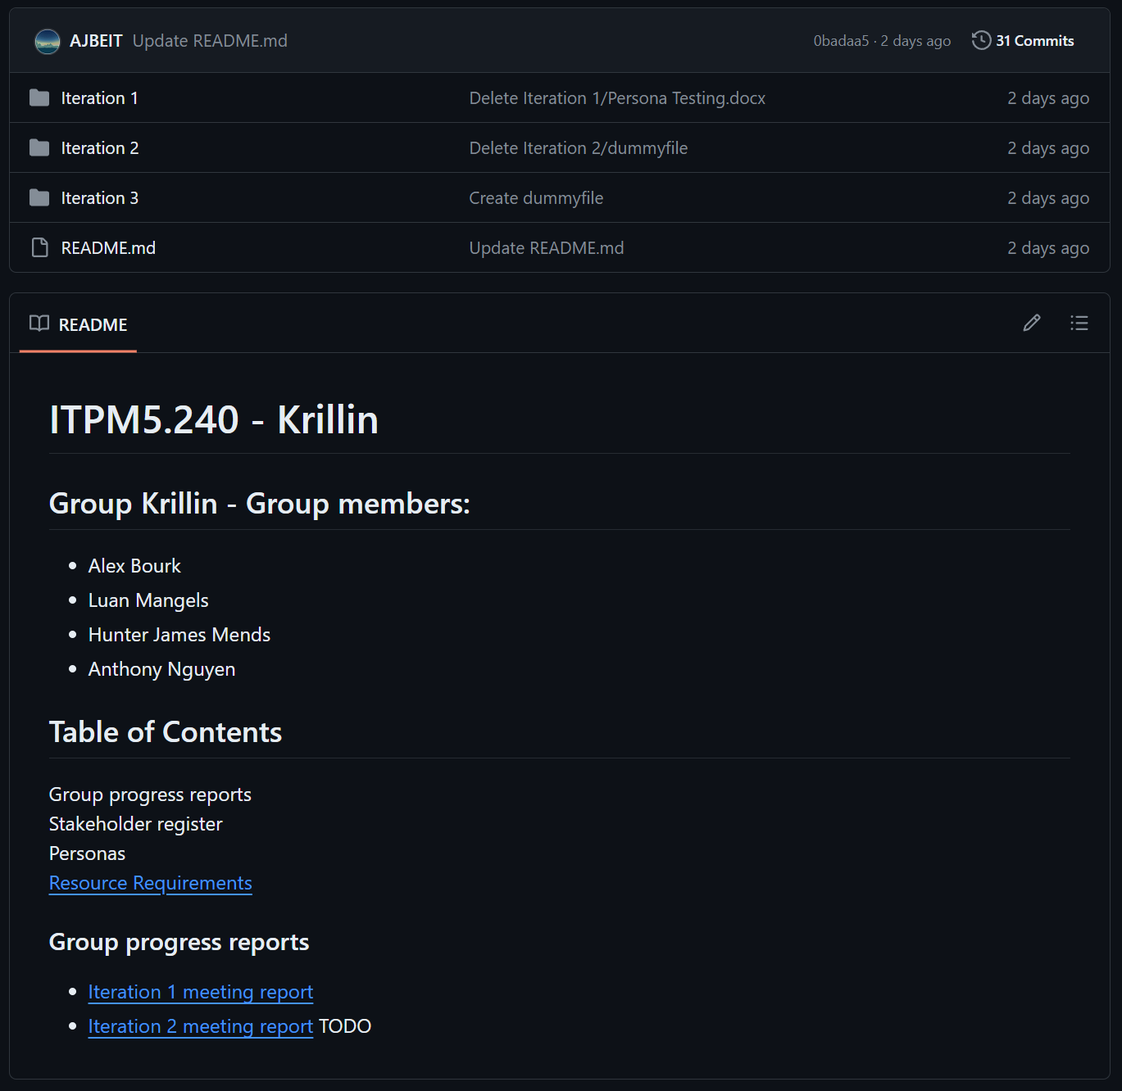

## *Meeting Report (Luan + Group):*



